BAYESIAN FS

COMPARISON BAYESIAN AND NON BAYESIAN ENVELOPES

Below is a comparison between frequentist (blue lines) and Bayesian bands (black lines)

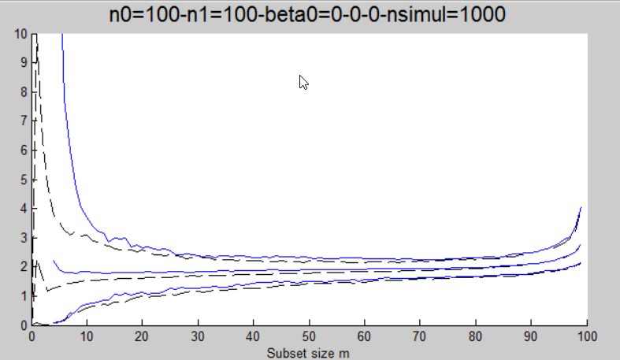Bayesian envelopes of MDR are generally smaller than frequentist envelopes.

As m tends to n the difference decreases

Larger is the ratio n0/n1 larger is the gap between frequentist and Bayesian envelopes

Other comparisons are given below

p=3;

n0=10000;

n1=1000;

nsimul=1000;

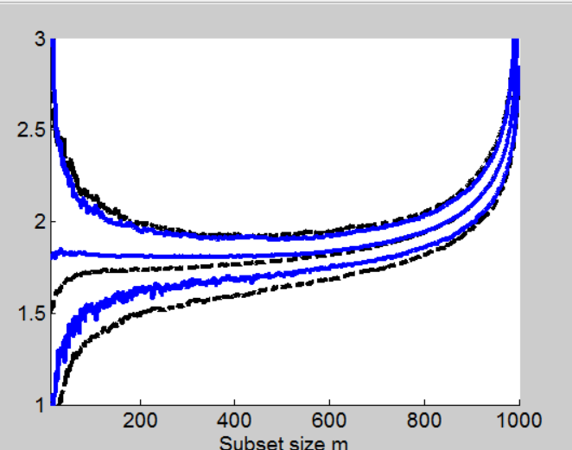

truesigma2=5;

% PRIOR INFORMATION definition setup

p=3;

n0=10;

n1=1000;

nsimul=1000;

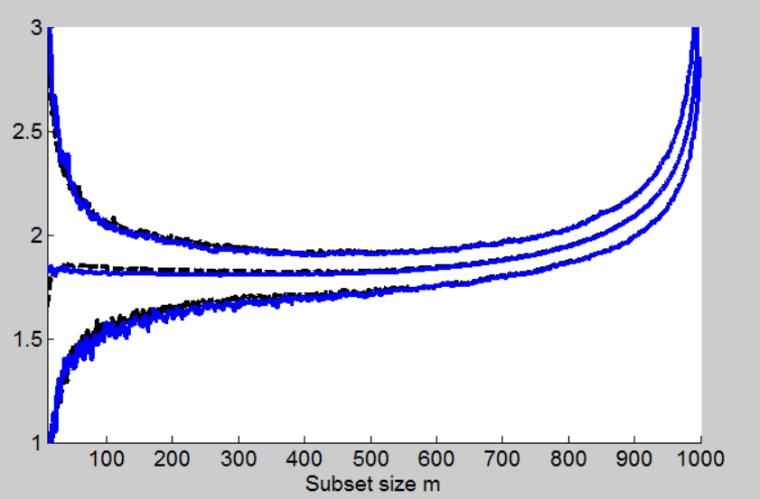

The agreement between frequentist and Bayesian bands seems better for upper envelopes rather than lower envelopes.

We are lucky because although lower envelopes are very different upper envelopes do seem the same so we can use the previous non Bayesian framework. However, it must be remarked that standard errors will be much smaller in the Bayesian case and therefore the power of the tests will be much greater in the Bayesian framework.

Comparison of fwd standard error for an element of beta

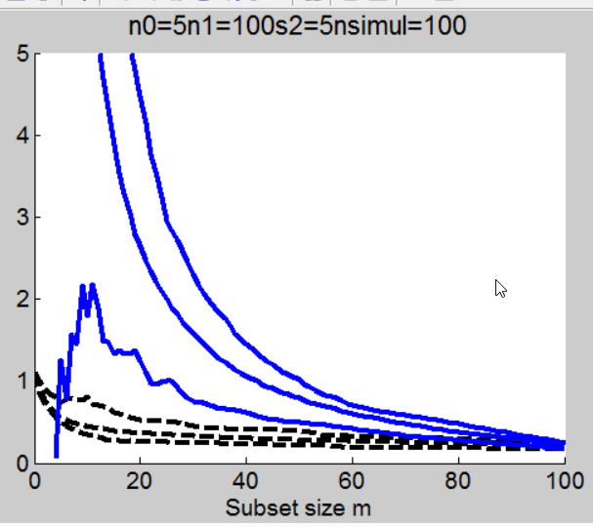

Now an ANALYSIS OF THE BEHAVIOUR OF BAYESIAN ENVELOPES when m=1.

When m=1, 2, …, (in every step of the search) we divide values of Xb and yb by sqrt of Tallis factor. Below is a plot of Tallis factor in the y axis. (x axis is subset size).

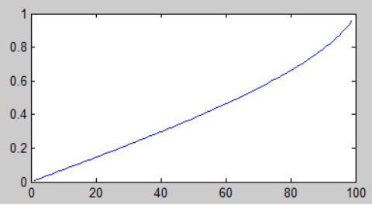

Due to rescaling when m=1, both Xb and yb can be very extreme because we divide by something which is very close to zero. This explains why the Bayesian mdr is very close to zero when m=0 but then has a dramatic upward jump when m=1 and then starts decreasing.

The distribution of values of Bayesian mdr (1000 simulations) when n=100 for four different values of m is given below

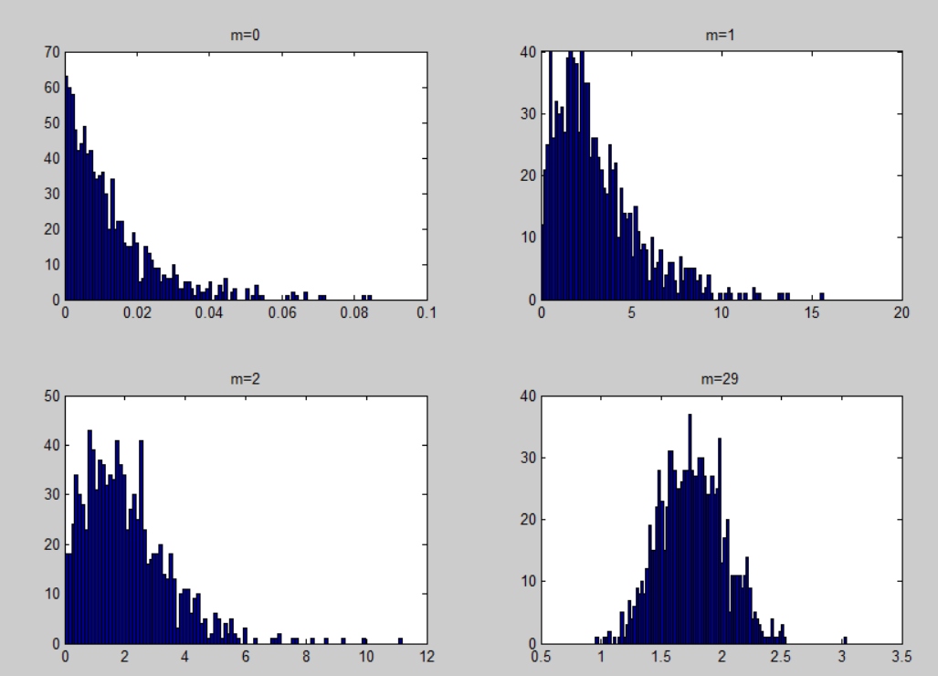

COMPARISON BETWEEN FRQUENTIST AND BAYESIAN ENVELOPES WHEN SOMETHING IS MISSPECIFIED

True sigma2 is 5 and prior of sigma2 is 10

Effect: curve of MDR are lower (see left panel of Figure below)

Envelopes of sigma2 (start much higher but converge to the true values

Blue lines = non Bayesian MDR

Black = Bayesian bands

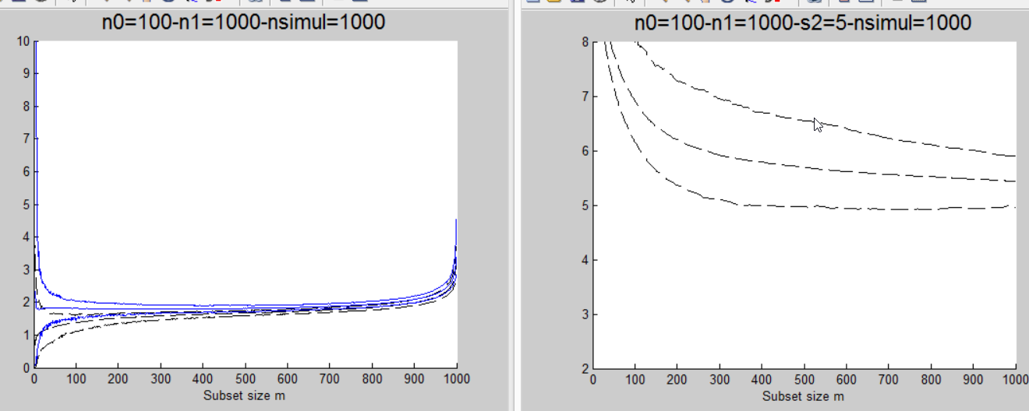

Remark: the convergence to the true values for s2 depends on n0. As n0 increases the convergence to the correct values is much slower (in the plot below the true value of sigma2 is 5). Note also that the width of the bands in the right panel is larger.

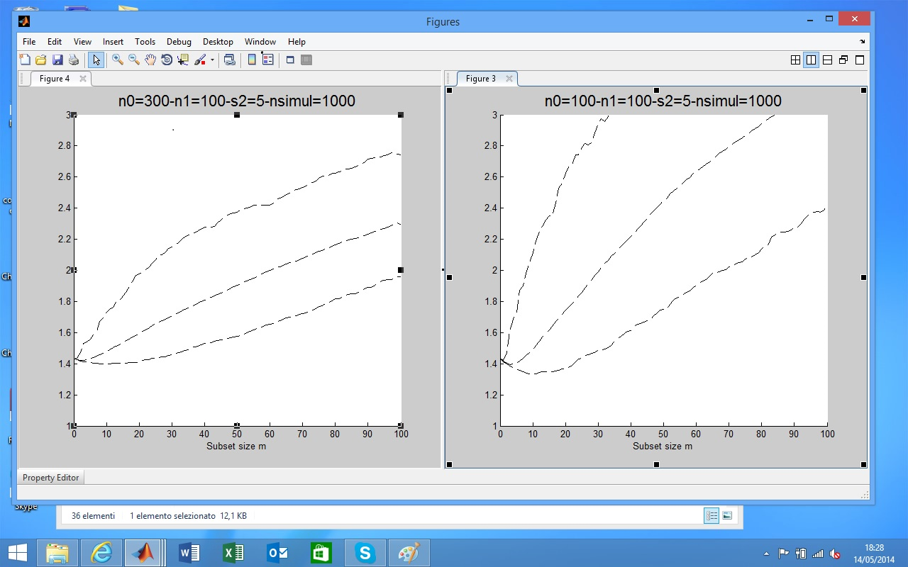

Now below we analyze the convergence of elements of beta.

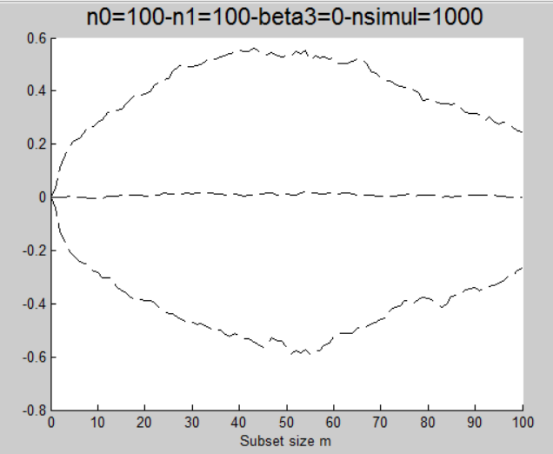

The rate of convergence to true values is the same for beta and sigma2?

Each time the same simulation but with different amount of prior information and analyze the effect on the average power (that is on the proportion of outliers which are correctly declared as outliers).

THINGS TO DO

Compute average power with different values of the prior

Transform to normal coordinates

Find one or two real data example where Bayesian regression is used